**VPC ASSIGNMENT**

I built a network looking at the diagram given:

* Created a VPC which created an instance , 2 subnets and an EIP which was linked to the instance.
* I had to change the security group as it was not accessible to the internet.
* I created 2 more instances apart from the one created by the VPC called DB server i.e private and webserver i.e public

**INSTANCES**

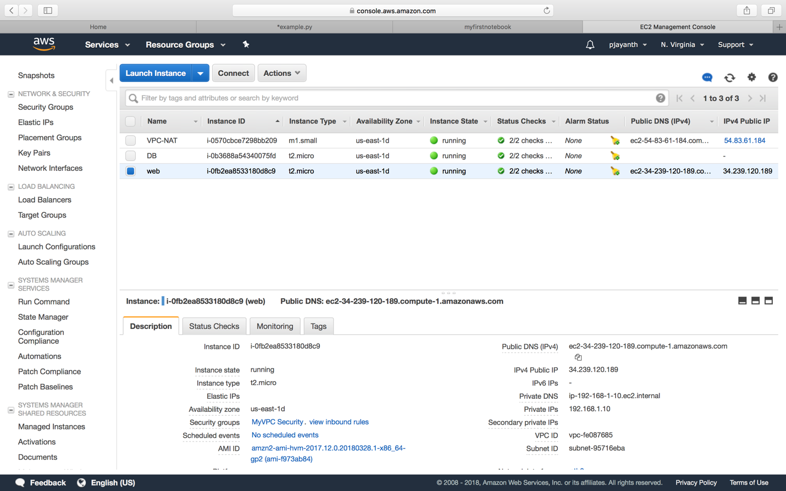

**VPC**

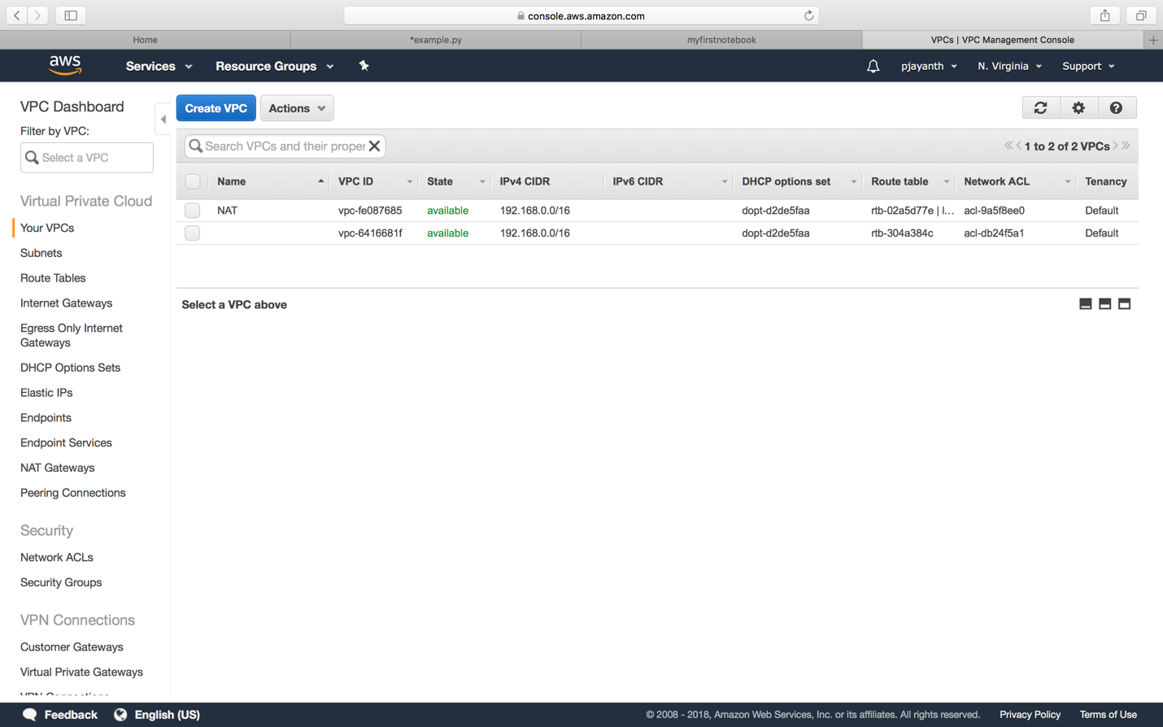

**SUBNETS**

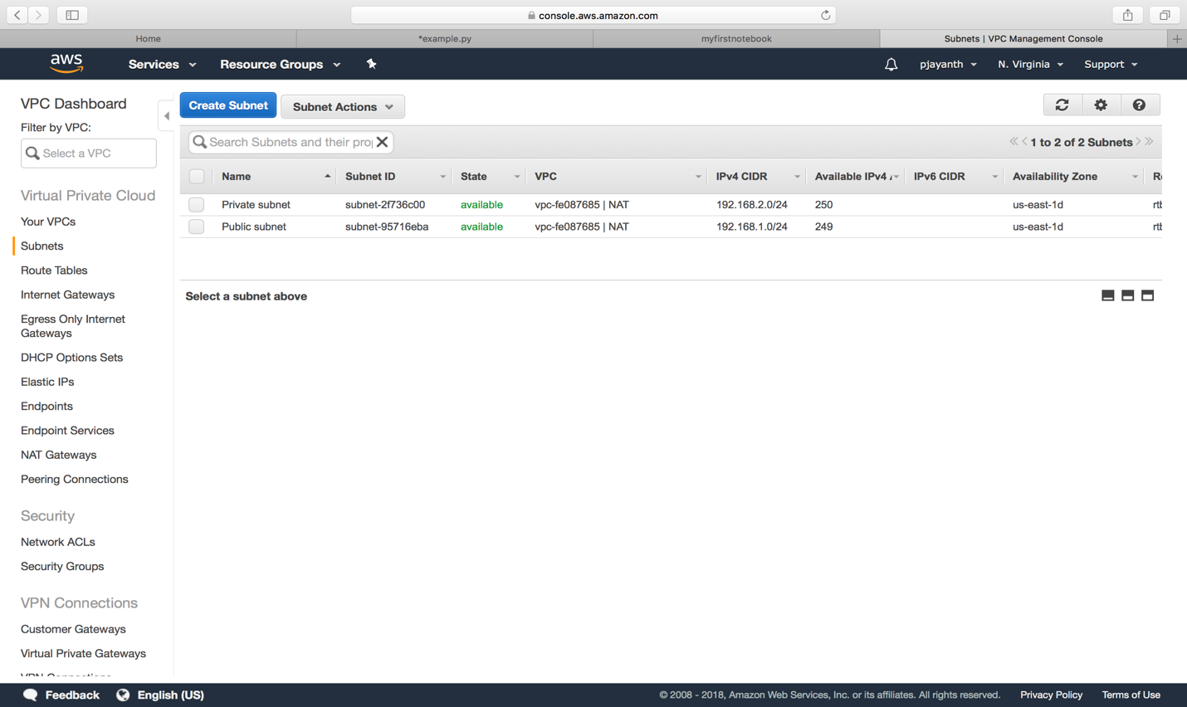

**PINGING FROM WEB SERVER**

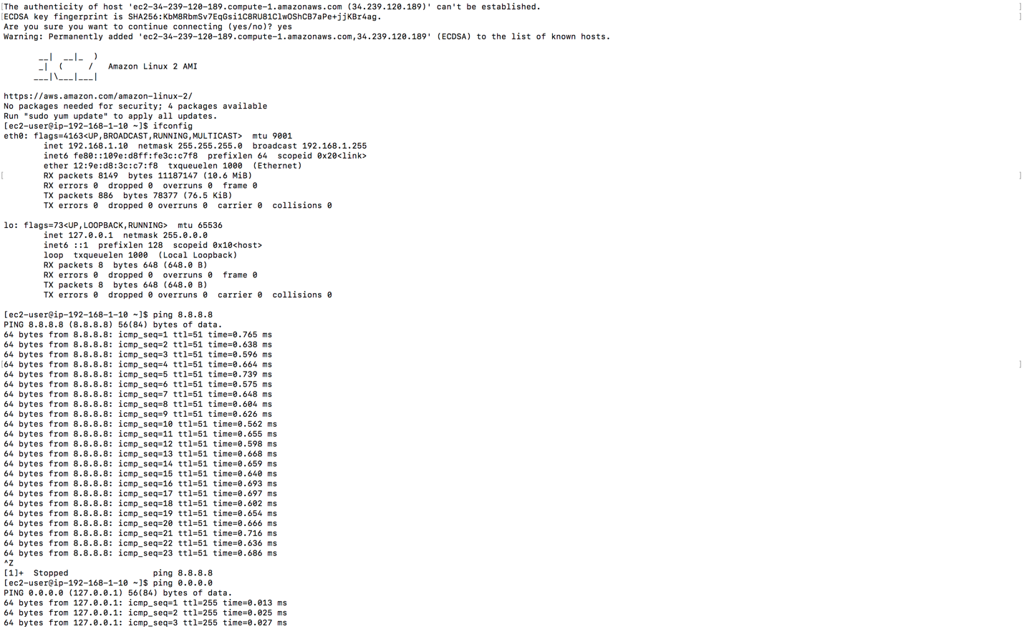

**PINGING DB FROM WEBSERVER**

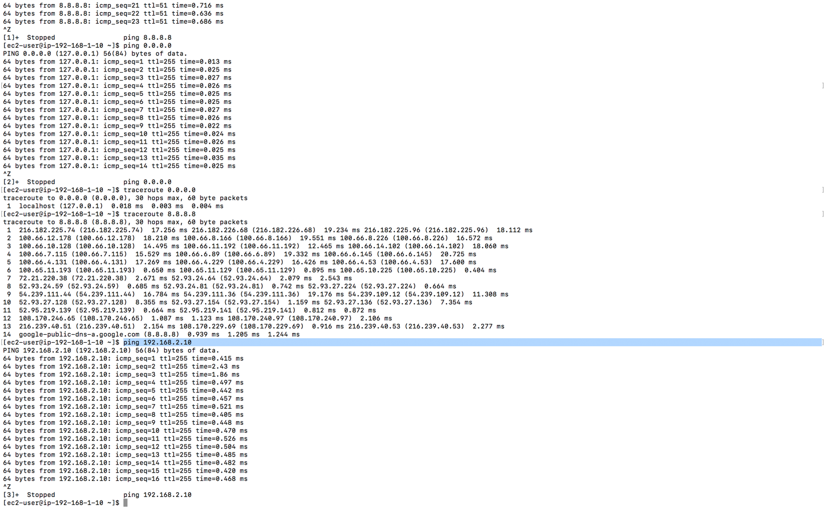

**PINGING DB**

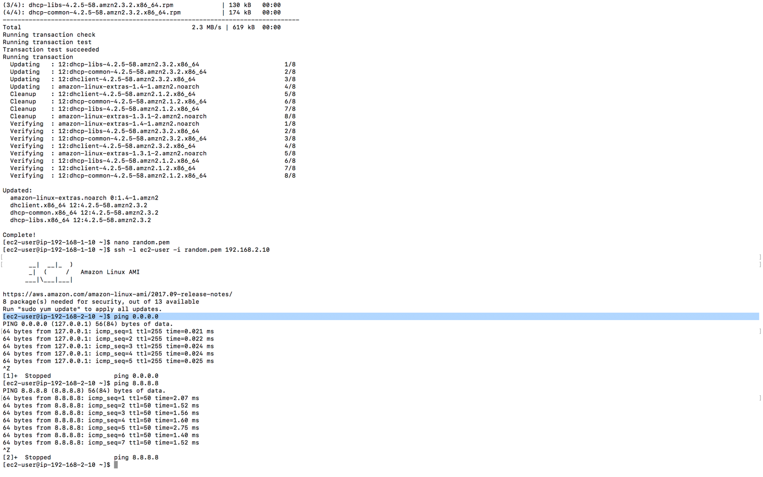

**TRACEROUTE**

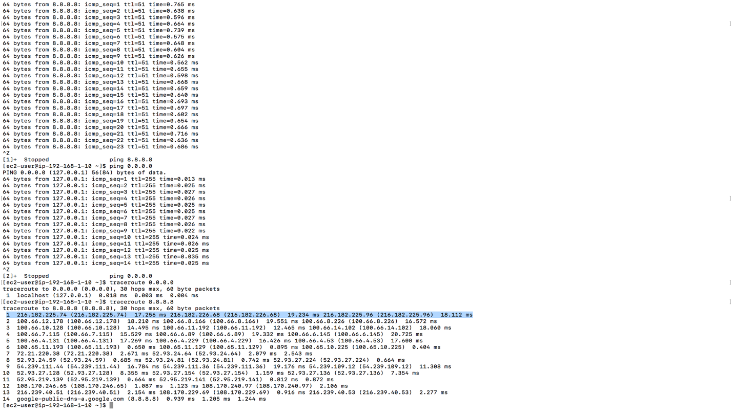

**1. What are the difference in configurations when using a NAT Instance Vs. a NAT**

**Gateway?**

* NAT gateway are highly available and created with redundancy in the availability zone.NAT gateway supports the bandwidth bursts of up to 10 Gbps.In case of NAT gateway, we don’t have to create an instance and instead we can directly create a NAT gateway and edit the route tables.
* In case of NAT instance: we create a new instance with the required VPC attached and then we edit the security groups and then we edit the corresponding route table and finally disable the source destination check.

**2. What are the limitations of a NAT Gateway compared to a NAT Instance?**

* NAT gateway returns an RST packet to any resources behind the NAT gateway that attempt to continue the connection.
* Bastion server is not supported in NAT Gateway.
* NAT Gateway Does not support fragmentation for TCP and ICMP protocols.
* Nat Instances have Less availability zones.
* Source/Destination check should be disabled in NAT Instances.

**3. What is Source/Destination Check?**

* We can disable the Source/Destination Check attribute for a NAT instance that's either running or stopped using the console or the command line.
* Source/Destination check is done to confirm that the instance is acting either as a source or destination. NAT instances on the other hand merely acts like a gateway for the traffic hence we disable Source/Destination check for NAT instances.

**THANKYOU**